Bran Andreea 244 FIECARE EXERCIRIU E PE O PAGINA SEPARATA

1.

SELECT * FROM

( SELECT *

FROM produs p

JOIN stoc s ON(s.cod_produs = p.id_produs)

WHERE s.cod_magazin=(

SELECT m2.id_magazin

FROM magazin m2

WHERE UPPER(m2.denumire) LIKE ('EMAG')

)

ORDER BY S.pret/p.user_rating desc) aux

WHERE rownum=1;

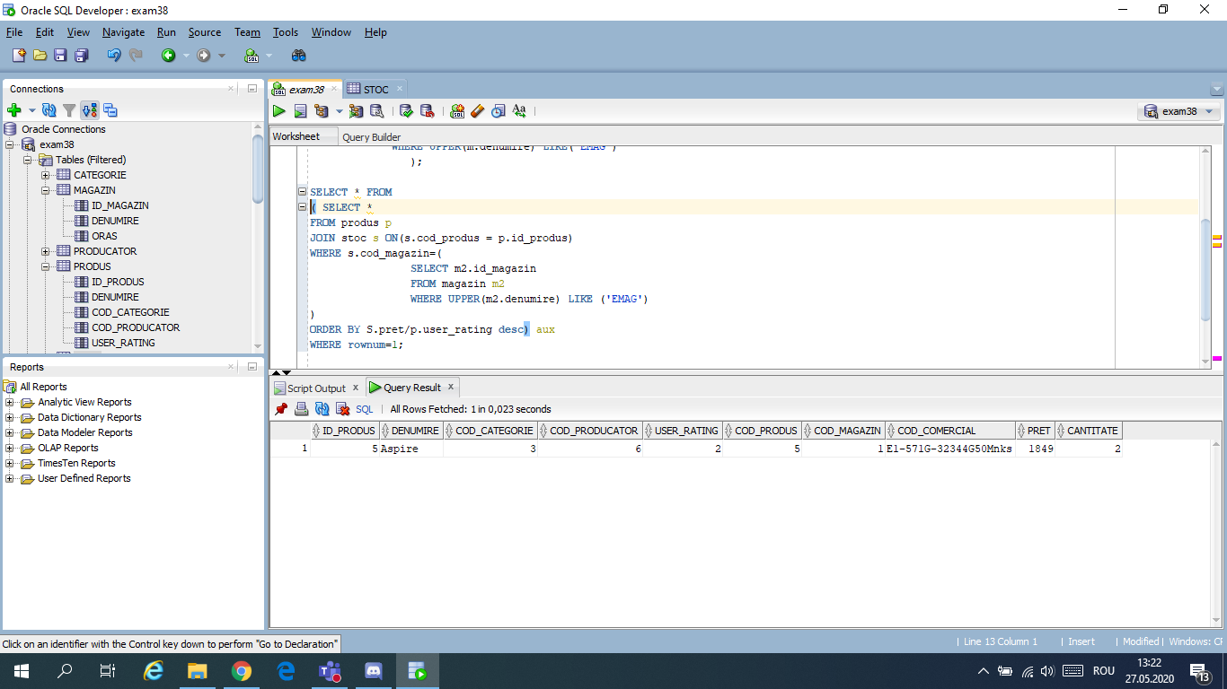

2. Sa se afiseze codul produselor care nu se comercializeaza in magazinele din Iasi.

SELECT DISTINCT st.cod_produs

FROM stoc st

WHERE NOT EXISTS(

SELECT 1

FROM magazin m

WHERE UPPER(m.oras) LIKE('IASI') AND NOT EXISTS(

SELECT 'x'

FROM stoc s

WHERE s.cod_magazin = m.id_magazin AND

st.cod_produs = s.cod_produs

)

);

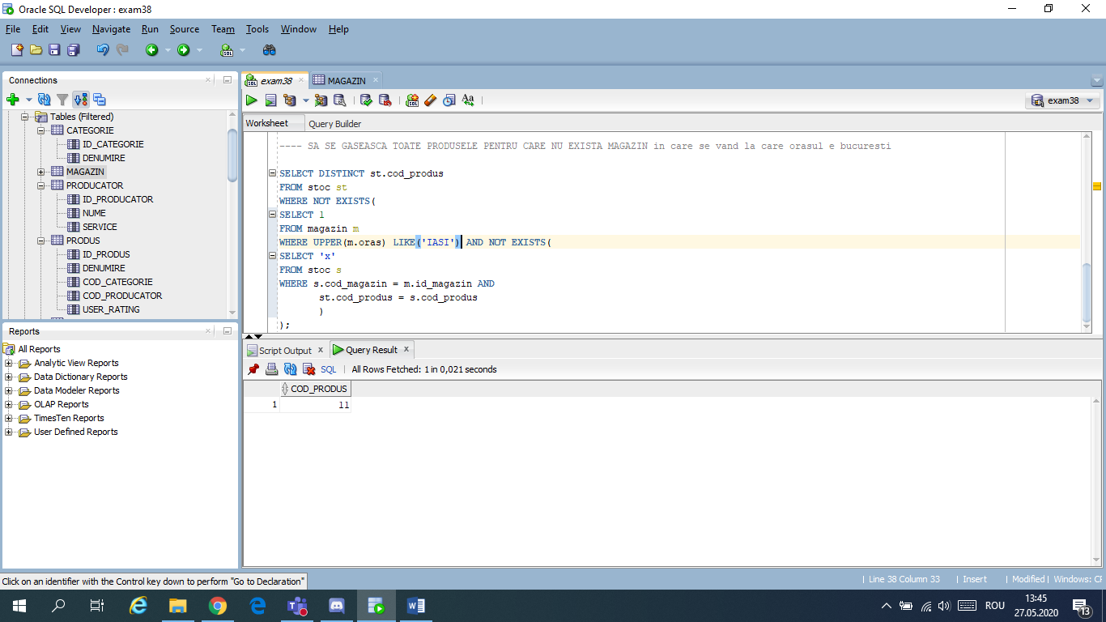

3. RENAME magazin TO magazin_abr;

ALTER TABLE magazin_abr

ADD valoare_stoc NUMBER(5,2);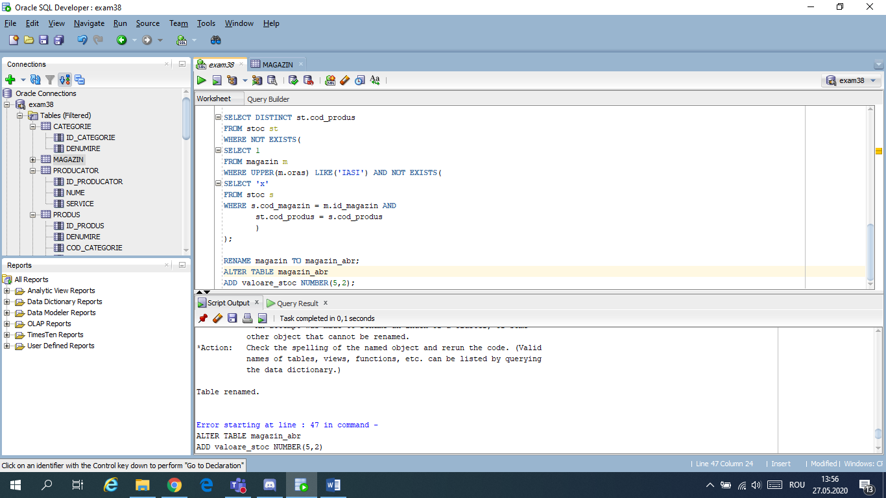

4. SELECT p.denumire, pr.nume, s.pret

FROM produs p

JOIN producator pr ON (p.cod_producator = pr.id_producator)

JOIN stoc s ON(s.cod_produs =p.id_produs AND s.pret BETWEEN 2000 AND 3000);

